Snell’s Law $n_{i}{\sin{θ}}_{i}=n_{r}{\sin{θ}}_{r}$

Refractive index $n=\frac{{\sin{θ}}_{i}}{{\sin{θ}}_{r}}$

$n=n$

Average



Sample standard deviation

$$percent error= \frac{\left|experimental-theoretical\right|}{theoretical} ×100$$

$$percent difference= \frac{\left|value 1-value 2\right|}{0.5\left(value 1+value 2\right)}$$

$$percent deviation=\frac{}{} ×100$$

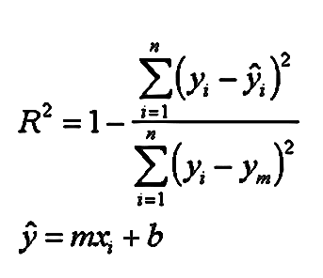

Results that fall outside x ± 3σn-1 are considered outliers